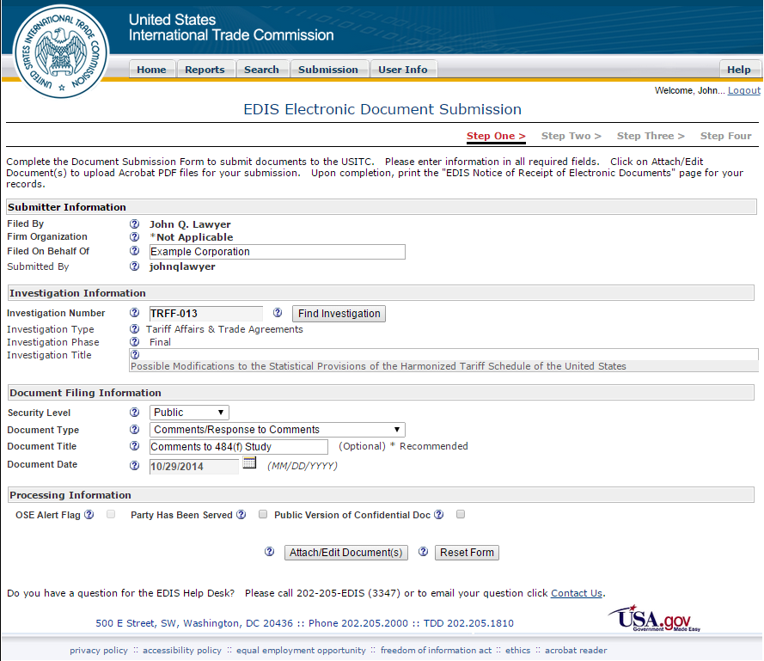

Please type the name of the person/organization on whose behalf you are filing the comments.

Please select investigation number **TRFF-013**

Please input the Document Filing Information exactly as shown. Be sure that the document you attach to your submission does in fact contain only public information.

Click this button to attach your comments to this submission. Your comments must be in PDF format.