LOST SALES AND LOST REVENUE SURVEY

FRESH WINTER STRAWBERRIES FROM MEXICO

This survey must be received by the Commission by January 14, 2026
See last page for instructions regarding how to file this questionnaire.

The information called for in this survey is for use by the United States International Trade Commission in connection with its antidumping investigation concerning fresh winter strawberries (“FWS”) from Mexico (Inv. No. 731-TA-1770 (Preliminary)). The information requested in the survey is requested under the authority of the Tariff Act of 1930, title VII. This report is mandatory and failure to reply as directed can result in a subpoena or other order to compel the submission of records or information in your possession (19 U.S.C. § 1333(a)). Further information on this survey can be obtained from Stephanie C. Myers Irizarry (202-205-2866, Stephanie.MyersIrizarry@usitc.gov).

Please enter your firm’s official name with proper capitalization and punctuation. Correct formatting is necessary for the Commission’s records.
Name of firm
Address
City State Zip Code
Website
Has your firm purchased fresh winter strawberries from any source (domestic or foreign), or imported fresh winter strawberries for your own retail sale or internal consumption, at any time since January 1, 2022?
NO (Sign the certification below and promptly return only this page of the survey to the Commission)
YES (Complete all parts of the survey, and return the entire survey to the Commission)

Return questionnaire via the Commission’s secure portal by clicking on the following link: https://usitc.gov/qportal. (PIN: BERRY, PHASE: PRELIMINARY). See last page for detailed instructions.
CERTIFICATION
I certify that the information herein supplied in this survey is complete and correct to the best of my knowledge and belief and understand that the information submitted is subject to audit and verification by the Commission. By submitting this certification I also grant consent for the Commission, and its employees and contract personnel, to use the information provided in this survey and throughout this proceeding in any other import-injury proceedings conducted by the Commission on the same or similar merchandise.

I, the undersigned, acknowledge that information submitted in response to this request for information and throughout this investigation or other proceeding may be disclosed to and used: (i) by the Commission, its employees and Offices, and contract personnel (a) for developing or maintaining the records of this or a related proceeding, or (b) in internal investigations, audits, reviews, and evaluations relating to the programs, personnel, and operations of the Commission including under 5 U.S.C. Appendix 3; or (ii) by U.S. government employees and contract personnel, solely for cybersecurity purposes. I understand that all contract personnel will sign appropriate nondisclosure agreements.

Name of Authorized Official Title of Authorized Official Date

Signature Phone Email address

GENERAL INFORMATION

Background.-- This proceeding was instituted in response to a petition filed on December 31, 2025, by the Strawberry Growers for Fair Trade. Antidumping duties may be assessed on the subject imports as a result of these proceedings if the Commission makes an affirmative determination of injury, threat, or material retardation, and if the U.S. Department of Commerce (“Commerce”) makes an affirmative determination of dumping. Pertinent information to this proceeding is available at:
Questionnaires: https://usitc.gov/reports/active_import_injury_questionnaires.
Other case information: https://ids.usitc.gov/case/8333/investigation/8854

Fresh winter strawberries (“FWS”) covered by this proceeding are all fresh and chilled winter strawberries (“fresh winter strawberries”) from Mexico harvested or entered during the period October 1 through March 31.

Fresh winter strawberries may be stemmed or de-stemmed, imported in bulk or loose form, or may be imported in individual containers packaged for retail sale. The scope of this investigation includes all fresh winter strawberries, whether or not organic, and irrespective of color, grade, shape, size, or packaging. Subject merchandise may be cleaned, coated, washed, waxed, inspected, subjected to metal detection, and/or vacuum cooled prior to importation.

Fresh winter strawberries covered by this investigation are classified under the following subheadings of the Harmonized Tariff Schedule of the United States (HTSUS), according to the season of importation: 0810.10.4040 and 0810.10.4080. Although the HTSUS numbers are provided for convenience and customs purposes, the written description of the scope of the investigation is dispositive.

All other (non-winter) fresh strawberries — All other fresh strawberries include fresh and chilled non-winter strawberries that are harvested or entered during the period April 1 through September 30.

Processed and/or frozen strawberries.—Excluded from the definitions of “fresh winter strawberries” and “all other (non-winter) fresh strawberries” are strawberries that have been frozen or processed by your firm prior to sale (for U.S. producers) and/or importation (for U.S. importers and/or U.S. purchasers). Note that shipments and/or imports of fresh (i.e., not yet frozen and/or not yet processed) strawberries intended eventually for the processed market are still included in the definitions of “fresh winter strawberries” and “all other (non-winter) fresh strawberries”.

Reporting of information.-- If information is not readily available from your records, provide carefully prepared estimates.

Confidentiality.--The data furnished in response to this survey that reveal the individual operations of your firm will be treated as confidential by the Commission to the extent that such data are not otherwise available to the public and will not be disclosed except as may be required by law (see 19 U.S.C. 1677f). Such confidential information will not be published in a manner that will reveal the individual operations of your firm; however, general characterizations of numerical business proprietary information (such as discussion of trends) will be treated as confidential business information only at the request of the submitter for good cause shown.

Release of information.--The information provided by your firm in response to this survey, as well as any other business proprietary information submitted by your firm to the Commission in connection with this proceeding, may become subject to, and released under, the administrative protective order provisions of the Tariff Act of 1930 (19 U.S.C. § 1677f) and section 207.7 of the Commission’s Rules of Practice and Procedure (19 CFR § 207.7). This means that certain lawyers and other authorized individuals may temporarily be given access to the information for use in connection with this proceeding or other import-injury proceedings conducted by the Commission on the same or similar merchandise; those individuals would be subject to severe penalties if the information were divulged to unauthorized individuals. Please also retain a copy of the final document that you submit.

Contact information.--Please identify the responsible individual and the manner by which Commission staff may contact that individual regarding the confidential information submitted in this survey. This may or may not be the person whose signature is at the bottom of page 1.

Name
Title
Email
Telephone

Firms operating more than one establishment should combine the data for all establishments into a single response.

In this survey, please use the following definitions for Within region and Out-of-region:

Out-of-region |  | Within region
Arizona | AZ | Alabama | AL
Arkansas | AR | Connecticut | CT
California | CA | Washington DC | DC
Colorado | CO | Delaware | DE
Hawaii | HI | Floria | FL
Idaho | ID | Georgia | GA
Iowa | IA | Illinois | IL
Kansas | KS | Indiana | IN
Minnesota | MN | Kentucky | KY
Missouri | MO | Louisiana | LA
Montana | MT | Michigan | MI
Nebraska | NE | Maryland | MD
Nevada | NV | Massachusetts | MA
New Mexico | NM | Mississippi | MS
North Dakota | ND | New Hampshire | NH
Oklahoma | OK | New Jersey | NJ
Oregon | OR | New York | NY
South Dakota | SD | North Carolina | NC
Utah | UT | Ohio | OH
Washington | WA | Pennsylvania | PA
American Samoa | AS | Rhode Island | RI
Guam | GU | South Carolina | SC
Northern Mariana Islands | MP | Tennessee | TN
 |  | Texas | TX
 |  | Vermont | VT
 |  | Virginia | VA
 |  | West Virginia | WV
 |  | Wisconsin | WI
 |  | Puerto Rico | PR
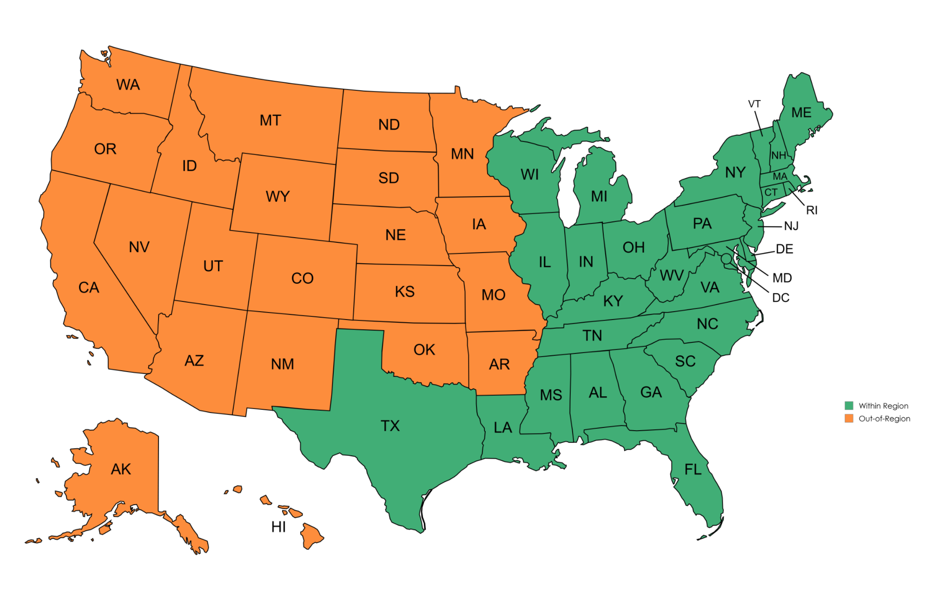
PURCHASE INFORMATION

1. Purchases and imports.— Report separately your firm’s domestic purchases and imports of fresh winter strawberries.

“Purchase” – Purchase from a U.S. entity, such as a U.S. producer, a U.S. importer, or other U.S. firm.

“Import” – Purchase directly from a foreign supplier, and your firm is the importer of record.

Item | 2022 | 2023 | 2024 | January—September 2025
Item | Quantity (in pounds)
Purchases of fresh winter strawberries produced in—
United States, that were produced/ harvested:
Within region
Out-of-region
Mexico
All other countries¹
Sources unknown²
Total purchases | 0 | 0 | 0 | 0
Imports of fresh winter strawberries from—
Mexico
All other countries¹
Total imports³ | 0 | 0 | 0 | 0
¹ Please identify these countries:
² Please indicate the firm(s) from which you purchased this merchandise:
³ If your firm imported fresh winter strawberries at any time since January 1, 2022, please also complete and return a U.S. importers' questionnaire in this proceeding.

2. Changes in purchasing patterns.— Please indicate whether the shares of your firm’s purchases of fresh winter strawberries steadily increased, fluctuated but ended higher, were constant, fluctuated but ended lower, or steadily decreased since January 1, 2022 from the listed sources.

Select one box per row.
Source of purchases | Did not purchase | Steadily increased | Fluctuated up | No change | Fluctuated down | Steadily decreased | Explanation for trend
United States
Mexico
All other countries
Sources unknown

3. Purchasing subject imports rather than domestic products.—

- Since January 1, 2022, did your firm import and/or purchase imports of fresh winter strawberries from Mexico (regardless of what regions purchased in/for) instead of purchasing fresh winter strawberries produced in the U.S.?

Import source | vs domestic source | Yes  (also respond to parts (b) and (c)) | No  (If “No”, skip to next question)
Mexico | United States produced/ harvested:  Within region
Mexico | United States produced/ harvested:  Out-of-region

- If you responded “Yes” to part (a), was the imported product priced lower than the domestic product?

Import source | vs domestic source | Yes | No
Mexico | United States produced/ harvested:  Within region
Mexico | United States produced/ harvested:  Out-of-region

(c) If you responded “Yes” to part (a), was price a primary reason for importing and/or purchasing subject imports rather than domestic product? Note since these data are limited to purchases and/or imports of fresh winter strawberries, and fresh strawberries are perishable, most (but not necessarily all) of the data reported below should fall within the winter season months (i.e., October through March).

Import source | vs domestic source | Yes | If Yes, estimate the quantity of imports purchased and/or imported instead of domestic product since January 1, 2022¹ ²  (in pounds) |  | No | If No, please indicate the reason your firm imported and/or purchased imports instead of domestic product
Mexico | United States produced/ harvested:  Within region |  | January
Mexico | United States produced/ harvested:  Within region |  | February
Mexico | United States produced/ harvested:  Within region |  | March
Mexico | United States produced/ harvested:  Within region |  | April
Mexico | United States produced/ harvested:  Within region |  | May
Mexico | United States produced/ harvested:  Within region |  | June
Mexico | United States produced/ harvested:  Within region |  | July
Mexico | United States produced/ harvested:  Within region |  | August
Mexico | United States produced/ harvested:  Within region |  | September
Mexico | United States produced/ harvested:  Within region |  | October
Mexico | United States produced/ harvested:  Within region |  | November
Mexico | United States produced/ harvested:  Within region |  | December
Mexico | United States produced/ harvested:  Out-of-region |  | January
Mexico | United States produced/ harvested:  Out-of-region |  | February
Mexico | United States produced/ harvested:  Out-of-region |  | March
Mexico | United States produced/ harvested:  Out-of-region |  | April
Mexico | United States produced/ harvested:  Out-of-region |  | May
Mexico | United States produced/ harvested:  Out-of-region |  | June
Mexico | United States produced/ harvested:  Out-of-region |  | July
Mexico | United States produced/ harvested:  Out-of-region |  | August
Mexico | United States produced/ harvested:  Out-of-region |  | September
Mexico | United States produced/ harvested:  Out-of-region |  | October
Mexico | United States produced/ harvested:  Out-of-region |  | November
Mexico | United States produced/ harvested:  Out-of-region |  | December
¹ If the quantity reported above exceeds the total quantity reported in Question 1, please explain.
² The by month line would represent each month since the beginning of the data collection period for which the full month is in the past (e.g., October = October 2022 + October 2023 + October 2024 + October 2025).

4. U.S. producers and import competition.—

(a) Since January 1, 2022, in connection with a sale or offer to sell FWS to your firm, did U.S. producers reduce their prices of domestically produced FWS in order to compete with lower-priced imports of fresh winter strawberries from Mexico?

Source | Yes (also respond to question part (b)) | No (If “No,” skip to next question) | Don’t know
Mexico

(b) If your firm responded “yes” to any of the above countries, please provide an estimate of the reduction in U.S. producers’ prices and any additional explanations.

Source | Estimated reduction in U.S. prices  (percent) |  | Additional explanation, including such information as timing (e.g., months/years), frequency of price reductions, or other market/competitive factors
Mexico |  | %

5. Major purchasing factors.--Please list, in order of their importance, the main factors your firm considers in deciding from whom to purchase fresh winter strawberries.

1.
2.
3.
Please list any other factors that are very important in your purchase decisions:

6. Other explanations--Please provide any additional comments in this box.

7. Stock symbol information.-- If your firm or parent firm is publicly traded, please specify the stock exchange and trading symbol: .

8. External counsel.-- If your firm or parent firm is represented by external counsel in relation to this proceeding, please specify the name of the law firm and the lead attorney(s).

Law firm:
Lead attorney(s):

9. Reporting requirements.--Please report the actual number of hours required and the cost to your firm of completing this survey for use by the Office of Management and Budget.

Hours | Dollars

Public reporting burden for this survey is estimated to average 4 hours per response, including the time for reviewing instructions, gathering data, and completing and reviewing the survey.

We welcome comments regarding the accuracy of this burden estimate, suggestions for reducing the burden, and any suggestions for improving this questionnaire. Please provide such comments to the Office of Investigations, import_injury@usitc.gov.

HOW TO FILE YOUR SURVEY RESPONSE

Please do not attempt to modify the format or permissions of the survey document. Please submit the completed survey using one of the methods noted below. If your firm is unable to complete the MS Word survey or cannot use one of the electronic methods of submission, please contact the Commission for further instructions.

• Upload via Secure Drop Box.— The questionnaire must be uploaded in two formats: (1) a Microsoft Word document; and (2) a PDF copy of the complete questionnaire with a signature on the first page. Please include any attachments at the end of the PDF (e.g., APO certification, additional comments, etc.).
Web address: https://usitc.gov/qportal Pin: BERRY Phase: Preliminary

• E-mail.— E-mail the MS Word questionnaire to stephanie.myersirizarry@usitc.gov; include a PDF copy of the complete questionnaire with a signature on the first page. Submitters are strongly encouraged to encrypt nonpublic documents that are electronically transmitted to the Commission to protect your sensitive information from unauthorized disclosure. The USITC secure submission portal and the Electronic Document Information System (EDIS) use Federal Information Processing Standards (FIPS) 140-2 cryptographic algorithms to encrypt data in transit. Submitting your nonpublic documents by a means that does not use these encryption algorithms (such as by email) may subject your firm’s nonpublic information to unauthorized disclosure during transmission. If you choose a non-encrypted method of electronic transmission, the Commission warns you that the risk of such possible unauthorized disclosure is assumed by you and not by the Commission.

If your firm did not purchase this product, please fill out page 1, print, sign, and submit a scanned PDF copy via the Commission’s secure submission portal or email.

The entities that comprise the Strawberry Growers for Fair Trade are: Astin Strawberry Exchange, BBI Produce, Inc. dba Berry Boss, Florida Department of Agriculture and Consumer Services, Grimes Produce Company, Mathis Farms, Simmons Farms, Inc., Sizemore Farms, Inc., Sweet Life Farms, Ultra Farms, and the Florida Strawberry Growers Association.

