FOREIGN PRODUCERS’/EXPORTERS’ QUESTIONNAIRE

FRESH WINTER STRAWBERRIES FROM MEXICO

This questionnaire must be received by the Commission by January 14. 2026
See last page for instructions regarding how to file this questionnaire.

The information called for in this questionnaire is for use by the United States International Trade Commission in connection with its antidumping investigation concerning fresh winter strawberries (“FWS”) from Mexico (Inv. No. 731-TA-1770 (Preliminary). The information requested in the questionnaire is requested under the authority of the Tariff Act of 1930, title VII.

Please enter your firm’s official name with proper capitalization and punctuation. This is the name that will appear on the Commission’s record for this proceeding.
Name of firm
Address
Website
Has your firm produced and/or exported fresh winter strawberries (as defined on next page) from Mexico at any time since January 1, 2022?
NO (Sign the certification below and promptly return only this page of the questionnaire to the Commission)
YES (Complete all parts of the questionnaire, and return the entire questionnaire to the Commission)

Return questionnaire via the Commission’s secure portal by clicking on the following link: https://usitc.gov/qportal. PIN: BERRY, Phase: PRELIMINARY). See last page for detailed instructions.
CERTIFICATION
I certify that the information herein supplied in response to this questionnaire is complete and correct to the best of my knowledge and belief and understand that the information submitted is subject to audit and verification by the Commission. By means of this certification I also grant consent for the Commission, and its employees and contract personnel, to use the information provided in this questionnaire and throughout this proceeding in any other import-injury proceedings conducted by the Commission on the same or similar merchandise.

I, the undersigned, acknowledge that information submitted in response to this request for information and throughout this proceeding or other proceedings may be disclosed to and used: (i) by the Commission, its employees and Offices, and contract personnel (a) for developing or maintaining the records of this or a related proceeding, or (b) in internal investigations, audits, reviews, and evaluations relating to the programs, personnel, and operations of the Commission including under 5 U.S.C. Appendix 3; or (ii) by U.S. government employees and contract personnel, solely for cybersecurity purposes. I understand that all contract personnel will sign appropriate nondisclosure agreements.

Name of Authorized Official Title of Authorized Official Date

Signature Phone Email address

PART I. GENERAL INFORMATION

Background. This proceeding was instituted in response to a petition filed on December 31, 2025, by the Strawberry Growers for Fair Trade. Antidumping duties may be assessed on the subject imports as a result of these proceedings if the Commission makes an affirmative determination of injury, threat, or material retardation, and if the U.S. Department of Commerce (“Commerce”) makes an affirmative determination of dumping. Pertinent information to this proceeding is available at:
Questionnaires: https://usitc.gov/reports/active_import_injury_questionnaires.
Other case information: https://ids.usitc.gov/case/8333/investigation/8854

Fresh winter strawberries (“FWS”) covered by this proceeding are all fresh and chilled winter strawberries (“fresh winter strawberries”) from Mexico harvested or entered during the period October 1 through March 31.

Fresh winter strawberries may be stemmed or de-stemmed, imported in bulk or loose form, or may be imported in individual containers packaged for retail sale. The scope of this investigation includes all fresh winter strawberries, whether or not organic, and irrespective of color, grade, shape, size, or packaging. Subject merchandise may be cleaned, coated, washed, waxed, inspected, subjected to metal detection, and/or vacuum cooled prior to importation.

Fresh winter strawberries covered by this investigation are classified under the following subheadings of the Harmonized Tariff Schedule of the United States (HTSUS), according to the season of importation: 0810.10.4040 and 0810.10.4080. Although the HTSUS numbers are provided for convenience and customs purposes, the written description of the scope of the investigation is dispositive.

All other (non-winter) fresh strawberries. — All other fresh strawberries include fresh and chilled non-winter strawberries that are harvested or entered during the period April 1 through September 30.

Processed and/or frozen strawberries.— Excluded from the definitions of “fresh winter strawberries” and “all other (non-winter) fresh strawberries” are strawberries that have been frozen or processed by your firm prior to sale (for U.S. producers) and/or importation (for U.S. importers and/or U.S. purchasers). Note that shipments and/or imports of fresh (i.e., not yet frozen and/or not yet processed) strawberries intended eventually for the processed market are still included in the definitions of “fresh winter strawberries” and “all other (non-winter) fresh strawberries”.

Reporting of information. If information is not readily available from your records, provide carefully prepared estimates. If your firm is completing more than one questionnaire (i.e., a producer, importer, purchaser and/or foreign producer questionnaire), you need not respond to duplicated questions.

Confidentiality. The commercial and financial data furnished in response to this questionnaire that reveal the individual operations of your firm will be treated as confidential by the Commission to the extent that such data are not otherwise available to the public and will not be disclosed except as may be required by law (see 19 U.S.C. §1677f). Such confidential information will not be published in a manner that will reveal the individual operations of your firm; however, general characterizations of numerical business proprietary information (such as discussion of trends) will be treated as confidential business information only at the request of the submitter for good cause shown.

Verification. The information submitted in this questionnaire is subject to audit and verification by the Commission. To facilitate possible verification of data, please keep all files, worksheets, and supporting documents used in the preparation of the questionnaire response. Please also retain a copy of the final document that you submit.

Release of information. The information provided by your firm in response to this questionnaire, as well as any other business proprietary information submitted by your firm to the Commission in connection with this proceeding, may become subject to, and released under, the administrative protective order provisions of the Tariff Act of 1930 (19 U.S.C. § 1677f) and section 207.7 of the Commission’s Rules of Practice and Procedure (19 CFR § 207.7). This means that certain lawyers and other authorized individuals may temporarily be given access to the information for use in connection with this proceeding or other import-injury proceedings conducted by the Commission on the same or similar merchandise; those individuals would be subject to severe penalties if the information were divulged to unauthorized individuals.

Valid number error messages. If you are completing this form in a country that uses periods (“.”) to delineate multiples of 1000 (e.g., one million would appear as $1.000.000 rather than $1,000,000), you may be unable to enter in numbers greater than 999 in numeric form fields. The solution to this data entry issue is to temporarily change your operating system’s number formatting to be consistent with the U.S. number formatting system while you complete this form. Detailed instructions on how to resolve this issue are provided at the end of this questionnaire and are available upon request from Caitlyn Costello (202-205-2058, Caitlyn.Costello@usitc.gov).

I-1. Reporting requirements. Please report below the actual number of hours required and the cost to your firm of completing this questionnaire for use by the Office of Management and Budget.

Hours | Dollars

Public reporting burden for this questionnaire is estimated to average 30 hours per response, including the time for reviewing instructions, gathering data, and completing and reviewing the questionnaire.

We welcome comments regarding the accuracy of this burden estimate, suggestions for reducing the burden, and any suggestions for improving this questionnaire. Please provide such comments to the Office of Investigations, import_injury@usitc.gov.

I-2. Establishments covered. Provide the name and address of establishment(s) covered by this questionnaire.

“Establishment” —Each facility of a firm in Mexico involved in the production or export of FWS, including auxiliary facilities operated in conjunction with (whether or not physically separate from) such facilities. Firms operating more than one establishment in Mexico should combine the data for all establishments into a single report.

“Related firm” —A firm that your firm solely or jointly owned, managed, or otherwise controlled; a firm that solely or jointly owned, managed, or otherwise controlled your firm; and/or a firm that was solely or jointly owned, managed, or otherwise controlled by a firm that also solely or jointly owned, managed, or otherwise controlled your firm.

I-3. Related producers. Does your firm or any related firm produce, have the capability to produce, or have any plans to produce FWS in the United States or other countries?

No | Yes | If yes, please name the firm(s) and country(ies) below and, if U.S. producer(s), ensure that they complete the Commission’s U.S. producers’ questionnaire.

I-4. Related U.S. importers. Does your firm or any related firm import or have any plans to import FWS into the United States?

No | Yes | If yes, please name the firm(s) below and ensure that they complete the Commission’s importer questionnaire.

I-5. Stock symbol information. If your firm or any of the entities reported in questions I-2 through I-4 are publicly traded in the United States, please specify the stock exchange and trading symbol (including American Depository Receipts, if applicable): .

I-6. External counsel. If your firm or parent firm is represented by external counsel in relation to this proceeding, please specify the name of the law firm and the lead attorney(s).

Law firm:
Lead attorney(s):

I-7. U.S. importers. Please provide the names, contacts, telephone numbers, and e-mail addresses of the TEN largest U.S. importers of your firm’s FWS since January 1, 2022.

Importer’s name |  | Contact person | Email | Telephone | Share of your firm’s 2024 U.S. exports (%)
1
2
3
4
5
6
7
8
9
10

PART II. TRADE AND RELATED INFORMATION

Further information on this part of the questionnaire can be obtained from Caitlyn Costello (202-205-2058, Caitlyn.Costello@usitc.gov). Supply all data requested on a calendar-year basis.

II-1. Contact information. Please identify the responsible individual and the manner by which Commission staff may contact that individual regarding the confidential information submitted in Part II.

Name
Title
Email
Telephone

II-2a. Changes in operations. Please indicate whether your firm has experienced any of the following changes in relation to the production of FWS since January 1, 2022.

Check as many as appropriate. |  | If checked, please describe the nature, timing / duration, and impact on operations of any such reported changes as well as the business reasons for them; leave completely blank if not applicable
 | Plant openings
 | Plant closings
 | Prolonged shutdowns
 | Production curtailments
 | Relocations
 | Expansions
 | Acquisitions
 | Consolidations
 | Weather-related or force majeure events
 | Other (e.g., revised labor agreements, technology)

II-2b. Anticipated changes in operations. Does your firm anticipate any changes in the character of its operations or organization (as noted above) relating to the production of FWS in the future?

No | Yes | If yes, supply details as to the likely timing, nature, and significance of such anticipated changes and describe the underlying assumptions and business reasons for them.

II-3. Share of sales. What percentage of your firm’s total sales in its most recent fiscal year was represented by sales of fresh winter strawberries? percent.

Products | Share of sales in 2024
Fresh winter strawberries (“FWS”) (as defined on p. 2) |  | %
All other strawberries |  | %
Other products¹ |  | %
¹ List the other products .

II-4. Third country trade actions. Are the FWS exported by your firm subject to antidumping/countervailing duty/safeguard findings, remedies, or proceedings?

No | Yes | If yes--List the products(s), countries affected, and the date of such findings/remedies/proceedings.

II-5. Trade data. Report your firm’s capacity, production, shipments, and inventories related to the production of FWS in your establishment(s) in Mexico during the specified periods. Do not include resales of FWS that your firm did not produce in this question; those data to the degree they are exported to the United States should only be reported in question II-6. Data in question II-5b should be limited to the production highlighted in blue in question II-5a.

Do not submit data by manufacturing facility if they are in the same country. If your firm has multiple manufacturing establishments within one country, you are required to combine data for those establishments within one foreign producer questionnaire response.

“Shipments” —Shipments of products produced in your establishment(s) in Mexico. Quantities reported should be net of returns.

“Home market commercial shipments” —Shipments, other than internal consumption and transfers to related firms, within Mexico.

“Home market internal consumption/transfers to related firms” —Shipments made to related firms in Mexico, including product consumed internally by your firm.

“Export shipments” —Shipments to destinations outside of the country indicated on page 1 (Mexico), including shipments to related firms.

“Inventories” —Finished goods inventory, not raw materials or work-in-progress.

“Practical fresh winter strawberry capacity” —The level of production of fresh winter strawberries that your establishment(s) could reasonably have expected to attain based on the actual product mix experienced over the winter harvest period (i.e., October through March). The level of production that your farm(s) or processing facility(ies) could reasonably have expected to attain, taking into account your firm’s actual product mix over the period and historical seasonal labor availability. This capacity measure is based on not only existing capital investments, i.e., machinery, equipment and land that is in place and ready to utilize and overall farm operations productivity (yield); but also any non-capital investment constraints, such as (1) normal operating conditions, including normal downtime for maintenance, repair, and cleanup; (2) your firm's existing in place and readily available labor force including expected seasonal workforce availability; (3) availability of material inputs; and (4) any other constraints (frosts, dry spells) that may have limited your firm's ability to produce the reported products. Importantly, this capacity measure is the maximum "practical" production your firm could have achieved without investing in new land or permanent staff (beyond the normal seasonable labor flexibilities), nor expanding the number of shifts operated in the period.

“Production” —All production in your establishment(s) in Mexico, including production consumed internally within your firm and production for another firm under a toll agreement.

Note: As requested in Part I of this questionnaire, please keep all supporting documents/records used in the preparation of the trade data, as Commission staff may contact your firm regarding questions on the trade data. The Commission may also request that your company submit copies of the supporting documents/records (such as production and sales schedules, inventory records, etc.) used to compile these data.

In table II-5, please use the following definitions for Within region and Out of region:
Out of region |  | Within region
Arizona | AZ | Alabama | AL
Arkansas | AR | Connecticut | CT
California | CA | Washington DC | DC
Colorado | CO | Delaware | DE
Hawaii | HI | Floria | FL
Idaho | ID | Georgia | GA
Iowa | IA | Illinois | IL
Kansas | KS | Indiana | IN
Minnesota | MN | Kentucky | KY
Missouri | MO | Louisiana | LA
Montana | MT | Michigan | MI
Nebraska | NE | Maryland | MD
Nevada | NV | Massachusetts | MA
New Mexico | NM | Mississippi | MS
North Dakota | ND | New Hampshire | NH
Oklahoma | OK | New Jersey | NJ
Oregon | OR | New York | NY
South Dakota | SD | North Carolina | NC
Utah | UT | Ohio | OH
Washington | WA | Pennsylvania | PA
American Samoa | AS | Rhode Island | RI
Guam | GU | South Carolina | SC
Northern Mariana Islands | MP | Tennessee | TN
 |  | Texas | TX
 |  | Vermont | VT
 |  | Virginia | VA
 |  | West Virginia | WV
 |  | Wisconsin | WI
 |  | Puerto Rico | PR
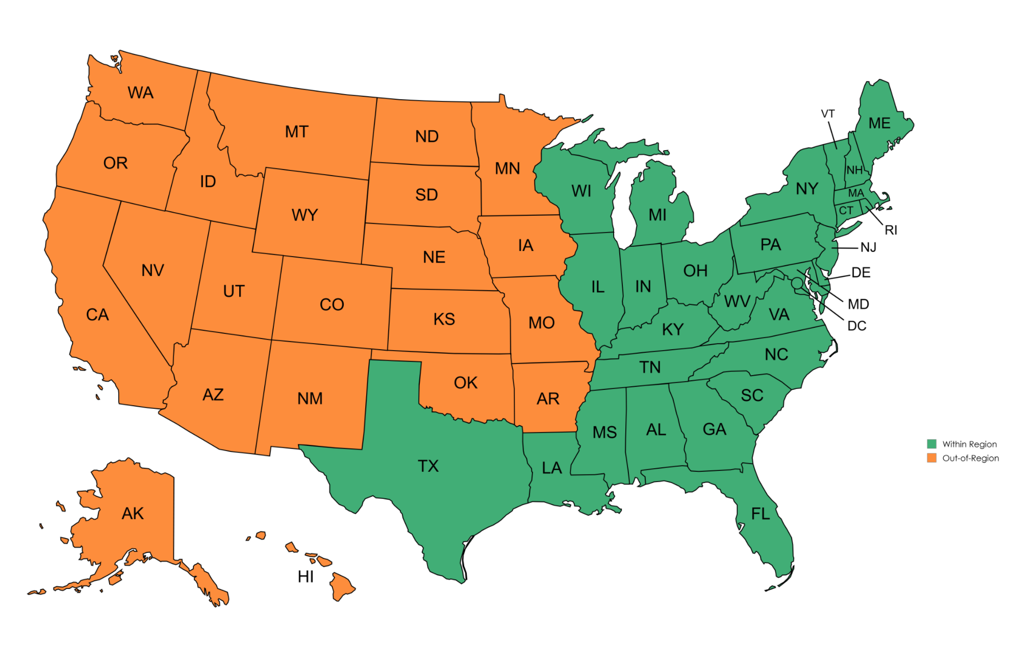
II-5a. Strawberry production in Mexico by use and month. Report your firm’s production of strawberries (whether or not “fresh”, and whether or not “winter”) in Mexico by month and use in the specified periods. Note the areas shaded in blue related to the data that should be included in question II-5b (below).

Period harvested | Production of strawberries (in pounds)
Period harvested | for processing | for fresh market
2022:
January (A)
February (B)
March (C)
April (D)
May (E)
June (F)
July (G)
August (H)
September (I)
October (J)
November (K)
December (L)
2023:
January (M)
February (N)
March (O)
April (P)
May (Q)
June (R)
July (S)
August (T)
September (U)
October (V)
November (W)
December (X)

II-5a. Strawberry production in Mexico by use and month- Continued.

Period harvested | Production of strawberries (in pounds)
Period harvested | for processing | for fresh market
2024:
January (Y)
February (Z)
March (AA)
April (AB)
May (AC)
June (AD)
July (AE)
August (AF)
September (AG)
October (AH)
November (AI)
December (AJ)
2025:
January (AK)
February (AL)
March (AM)
April (AN)
May (AO)
June (AP)
July (AQ)
August (AR)
September (AS)
October (AT)
November (AU)
December (AV)
2026 full year projections (AX), all months combined

II-5a. Strawberry production in Mexico by use and month- Continued.

SUM OF MONTHLY FWS PRODUCTION. The data reported for fresh market strawberries (2nd data column above) in the harvested “winter” months (October to March) as defined in the term fresh winter strawberries.

Item | Actual experience |  |  |  |  | Projections
Item | Calendar year |  |  | January-September |  | Calendar year
Item | 2022  (A + B + C + J + K + L) | 2023  (M + N + O + V + W + X) | 2024  (Y + Z + AA + AH + AI + AJ) | 2024  (Y + Z + AA) | 2025  (AK + AL + AM) | 2025  (AK + AL + AM + AT + AU + AV) | 2026  (AX)
Production of fresh winter strawberries | 0 | 0 | 0 | 0 | 0 | 0 | 0

II-5b. Trade data. Continued.

Quantity (in pounds)
Item | Actual experience |  |  |  |  | Projections¹
Item | Calendar year |  |  | January-September |  | Calendar year
Item | 2022 | 2023 | 2024 | 2024 | 2025 | 2025 | 2026
Practical fresh winter strawberry capacity (AY)
Beginning-of-period inventories (AZ)
Production, as summed in question II-5a above (BA) | 0 | 0 | 0 | 0 | 0 | 0 | 0
Home market shipments:
Internal consumption or transfers (BB)
Commercial shipments (BC)
Export shipments to:
The United States:
Within region (BD)
Out of region (BE)
Overall United States | 0 | 0 | 0 | 0 | 0 | 0 | 0
All other markets (BG)³
Total exports | 0 | 0 | 0 | 0 | 0 | 0 | 0
Total shipments | 0 | 0 | 0 | 0 | 0 | 0 | 0
Disposed of / spoilage (BH)
End-of-period inventories (BI)
¹ Explain the basis of your firm’s projections: .
² Identify your firm’s principal other export markets: .

II-5b. Trade data. Continued.

RECONCILIATION OF SHIPMENTS, PRODUCTION, AND INVENTORY. Generally, the data reported for the end-of-period inventories (i.e., line BI) should be equal to the beginning-of-period inventories (i.e., line AZ), plus production (i.e., line BA, which was pulled from question II-5a), less total shipments (i.e., lines BB, BC, BD, BE, BG) and product that was disposed of or spoiled (i.e., line BH). Please ensure that any differences are not due to data entry errors in completing this form, but rather actually reflect your firm’s records; and also provide any likely explanations for any differences (e.g., theft, loss, damage, record systems issues, etc.) if they exist.

Item | Actual experience |  |  |  |  | Projections
Item | Calendar year |  |  | January-September |  | Calendar year
Item | 2022 | 2023 | 2024 | 2024 | 2025 | 2025 | 2026
AZ + BA (summed from monthly data) – BB – BC – BD – BE – BG – BH – BI = should equal zero ("0") or provide an explanation.¹ | 0 | 0 | 0 | 0 | 0 | 0 | 0
¹ Explanation if the calculated fields above are returning values other than zero (i.e., “0”) but are nonetheless accurate: .

II-6. Exports to the United States not produced by your firm. Report your firm’s exports to the United States of FWS that was produced in Mexico but not by your firm during the specified periods. Note these data should not be included in question II-5a or II-5b.

Quantity (in pounds)
Item | Actual experience |  |  |  |  | Projections
Item | Calendar year |  |  | January-September |  | Calendar year
Item | 2022 | 2023 | 2024 | 2024 | 2025 | 2025 | 2026
Exports of FWS to the United States not produced by your firm, made to customers or locations:¹
Within region
Out-of-region
¹ List the producer(s). .

II-7. Export vs harvest timing. If there are exports to the United States that your firm makes within the October to March “winter harvest” period that were not harvested in those months (i.e., data are not included in II-5b), please quantify and describe how much of that occurs and are not included in the reported data. Likewise if there are exports to the United States included above that were harvested within the October to March period (i.e., are included in the data reported in II-5b), but were shipped/exported to the United States in the April to September period, please quantify and describe how much of that occurs are included in the reported data.

Exports to US: Exported Oct thru Mar (but not harvested in those months). Note these data should not be included in the data reported in II-5b.
Exports to US: Harvested Oct thru Mar (but not exported those months, i.e., exported Apr through September). Note these data should be included in the data reported in II-5b.

II-8. Other explanations. If your firm would like to further explain a response to a question in Part II for which a narrative box was not provided, please note the question number and the explanation in the space provided below. Please also use this space to highlight any issues your firm had in providing the data in this section, including but not limited to technical issues with the MS Word questionnaire.

Correcting Valid number error messages. If you are completing this questionnaire in a country that uses periods (“.”) to delineate multiples of 1000 (e.g., one million would appear as $1.000.000 instead of as $1,000,000), you may be unable to enter in numbers greater than 999 in numeric form fields. This issues stem from your computer number formatting setting (e.g., not the MS Word document itself, but the computer from which you are opening up the document). In the United States commas (,) delineate multiples of 1000 and periods (.) delineate fractions less than one. Many EU countries use the reverse where multiples of 1000 are delineated with periods (.) and fractions less than one are delineated with commas (,). This questionnaire is prepared in the United States with the U.S. number formatting. When this formatting interacts with a computer set to EU number formatting, we believe this may cause this issue.

The solution to this data entry issue is to temporarily change your operating system’s number formatting to be consistent with the U.S. number formatting system while you complete the questionnaire.

To temporarily change your computer’s number settings to U.S. settings, please do the following (for Microsoft Windows Operating system):
- START
- Control Panel
- Region and Language (under Clock, Language, and Region category)
- Format tab
- Change the Format from your existing one (e.g., “Italian (Italy)”) to “English (United States)” (see screen shots below)

When you do this the number “twelve million dollars and thirty five cents” would change from $12.000.000,35 (Italy format) to $12,000,000.35 (U.S. format), and then there will be no conflict with the USITC foreign producer questionnaire form. When you finish reporting the data then you can close the questionnaire and switch back to your country settings.

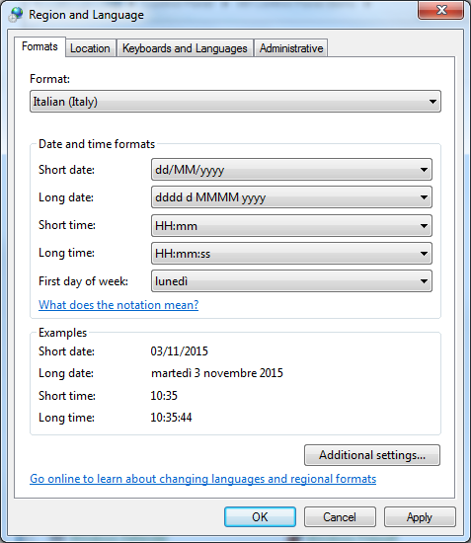 | 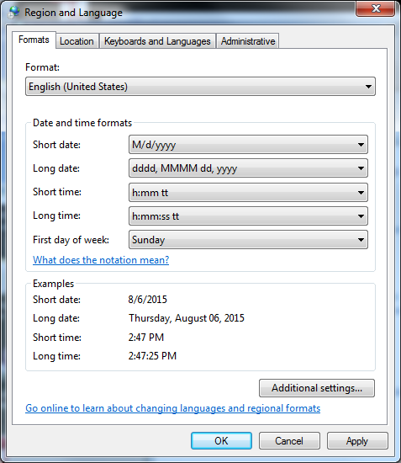

HOW TO FILE YOUR QUESTIONNAIRE RESPONSE

This questionnaire is available as a “fillable” form in MS Word format on the Commission’s website at: https://usitc.gov/reports/active_import_injury_questionnaires.

Please do not attempt to modify the format or permissions of the questionnaire document. Please submit the completed questionnaire using one of the methods noted below. If your firm is unable to complete the MS Word questionnaire or cannot use one of the electronic methods of submission, please contact the Commission for further instructions.

• Upload via Commission’s secure submission portal. The questionnaire must be uploaded in two formats: (1) a Microsoft Word document; and (2) a PDF copy of the complete questionnaire with a signature on the first page. Please include any attachments at the end of the PDF (e.g., APO certification, additional comments, etc.).
Web address: https://usitc.gov/qportal Pin: BERRY Phase: Preliminary
• E-mail. E-mail the MS Word questionnaire to Caitlyn.Costello@usitc.gov; include a PDF copy of the complete questionnaire with a signature on the first page. Submitters are strongly encouraged to encrypt nonpublic documents that are electronically transmitted to the Commission to protect your sensitive information from unauthorized disclosure. The USITC secure submission portal and the Electronic Document Information System (EDIS) use Federal Information Processing Standards (FIPS) 140-2 cryptographic algorithms to encrypt data in transit. Submitting your nonpublic documents by a means that does not use these encryption algorithms (such as by email) may subject your firm’s nonpublic information to unauthorized disclosure during transmission. If you choose a non-encrypted method of electronic transmission, the Commission warns you that the risk of such possible unauthorized disclosure is assumed by you and not by the Commission.

If your firm did not produce or export this product, please fill out page 1, print, sign, and submit a scanned PDF copy via the Commission’s secure submission portal or email.

Parties to this proceeding. If your firm is a party to this proceeding, it is required to serve a copy of the completed questionnaire on parties to the proceeding that are subject to administrative protective order (see 19 CFR § 207.7). A list of such parties may be obtained from the Commission’s Secretary (202-205-1802). A certificate of service must accompany the completed questionnaire you submit (see 19 CFR § 207.7). Service of the questionnaire must be made in paper form.

The entities that comprise the Strawberry Growers for Fair Trade are: Astin Strawberry Exchange, BBI Produce, Inc. dba Berry Boss, Florida Department of Agriculture and Consumer Services, Grimes Produce Company, Mathis Farms, Simmons Farms, Inc., Sizemore Farms, Inc., Sweet Life Farms, Ultra Farms, and the Florida Strawberry Growers Association.

